* Report View

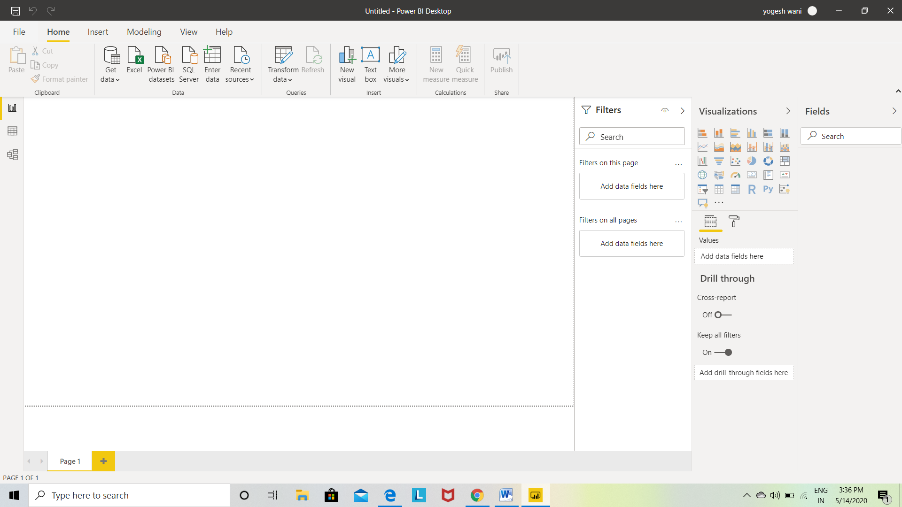

* Power Query Editor

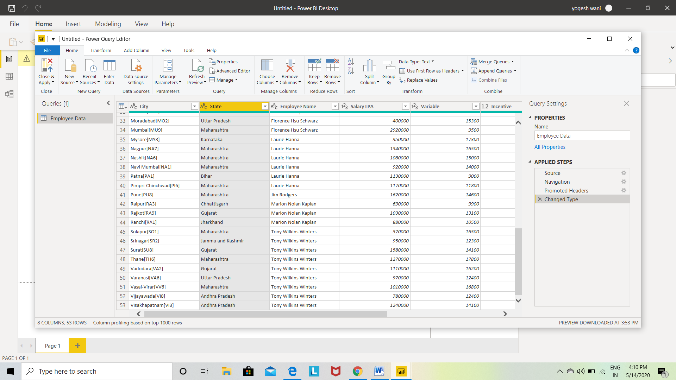

* Advanced Editor

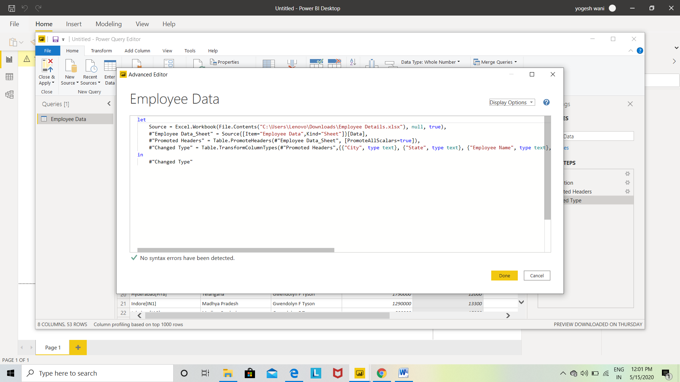

* Data View

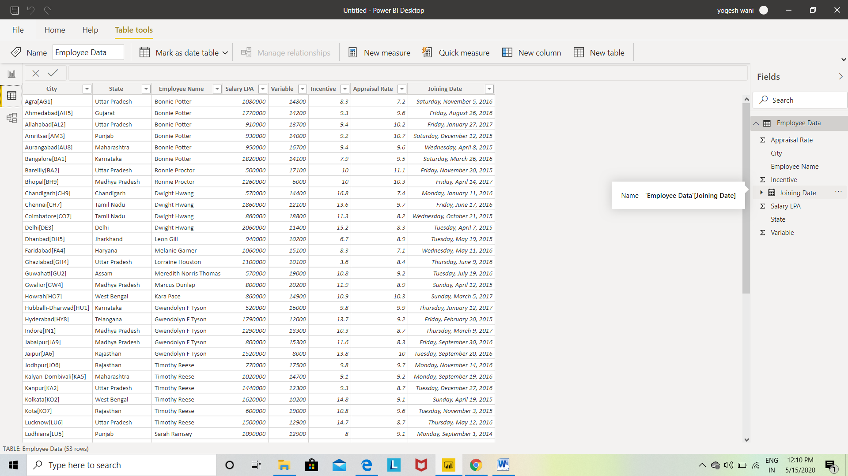

* Model View

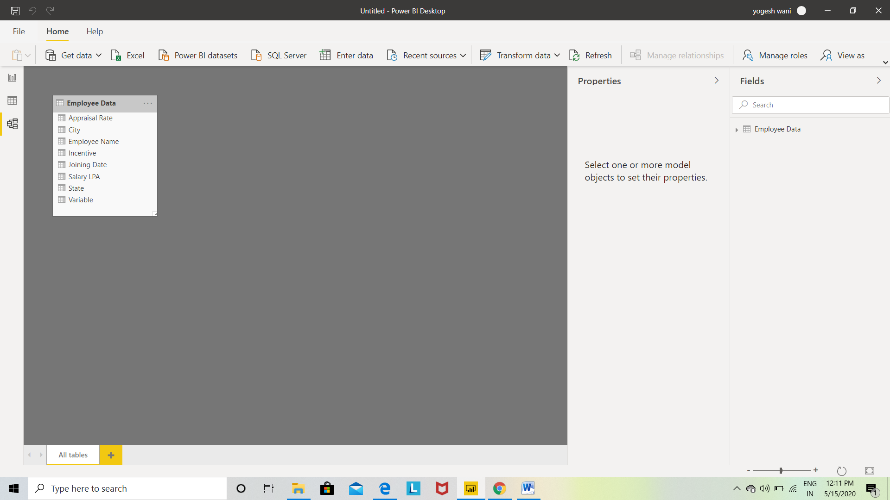

**Power BI Desktop :-**

Power BI Desktop is a free application you install on your local computer that lets you connect to, transform, and visualize your data. With Power BI Desktop, you can connect to multiple different sources of data, and combine them (often called modeling) into a data model. This data model lets you build visuals, and collections of visuals you can share as reports, with other people inside your organization. Most users who work on business intelligence projects use Power BI Desktop to create reports, and then use the Power BI service to share their reports with others.

The most common uses for Power BI Desktop are as follows:

* Connect to data
* Transform and clean that data, to create a data model
* Create visuals, such as charts or graphs, that provide visual representations of the data
* Create reports that are collections of visuals, on one or more report pages
* Share reports with others by using the Power BI service

**Power BI Pro :-**

Power BI Pro is an individual user license that lets users read and interact with reports and dashboards that others have published to the Power BI service. Users with this license type can share content and collaborate with other Power BI Pro users. Only Power BI Pro users can publish or share content with other users or consume content that's created by others, unless a Power BI Premium capacity hosts that content. For more information about the available types of licenses and subscription. The Pro plan costs $9.99/user/month. It includes data collaboration, data governance, building dashboards with a 360-degree real-time view and the ability to publish reports anywhere. Users can try it a free trial for 60 days before purchasing the subscription**.**

**Power BI Premium :-**

You can use Power BI Premium to get dedicated and enhanced resources for your organization, so users in your organization can use the Power BI service with better performance and responsiveness. For example, with a Power BI Premium subscription, you and your organization's users get access to:

* Greater scale and performance
* Flexibility to license by capacity
* Unify self-service and enterprise BI
* Extend on-premises BI with Power BI Report Server
* Support for data residency by region (Multi-Geo)
* Share data with anyone without purchasing a per-user license

The Premium plan starts at $4,995 **a** month per dedicated cloud compute and storage resource.